|  |  |
| --- | --- |
| *Flashing new firmware to ESP32* | |
| Prepared by | Mateusz Fiołek |
| Date | 01.02.2022 |

Table of contents

1Esp32 download tool installation 3

2Flashing new firmware 3

# ESP32 download tool installation

To flash new firmware to esp32 you need to download **ESP32 DOWNLOAD TOOL**.

1. From producer web page <https://www.espressif.com/en/support/download/other-tools> click and download **Flash Download Tools.**

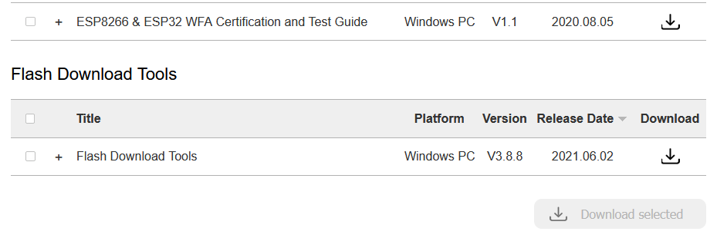

1. Unzip downloaded file.

# Flashing new firmware

1. **Turn off device from power**.
2. Run flash_download_tools.exe.
3. Select ChipType to ESP32 and WorkMode to develop and press OK button.

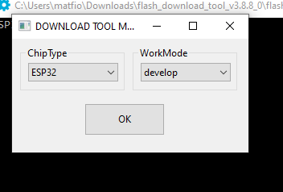

1. Now you need USB to UART (3.3 Volt) converter for example ttl-232.

Connect wires to the connector on the device:

* GND to J202 pin 1
* RXT to J202 pin 5
* TXT to J202 pin 4

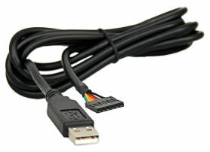

1. In general , you should use SPI download mode
2. The checkbox must be checked , provided file added and addresses selected.
3. COM Choose correct serial port number, if click the tool will auto-detect and list all available serial ports.
4. BAUD Choose communication speed. Currently we use 115200**.**
5. Press Start button.

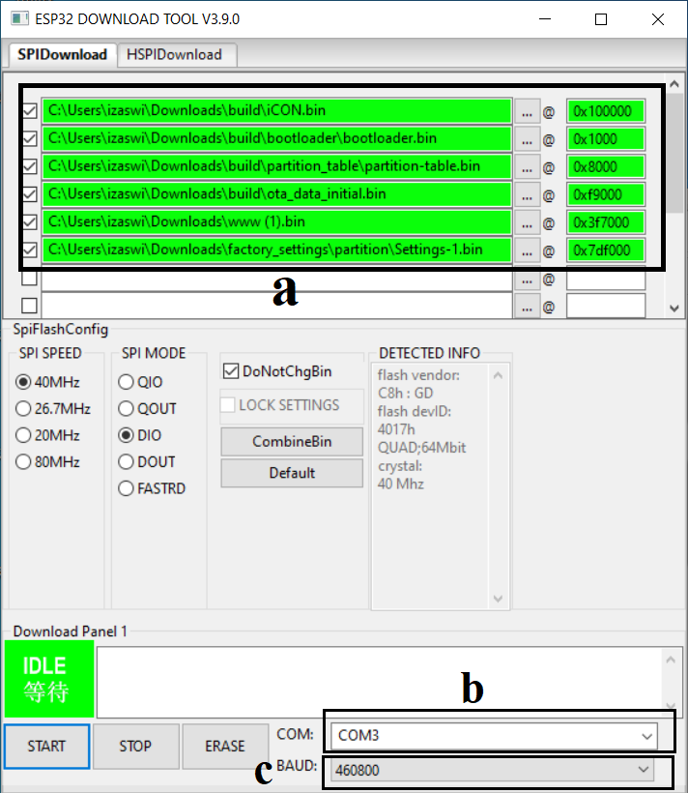

1. Press SW200 button and hold. Turn on device to power.

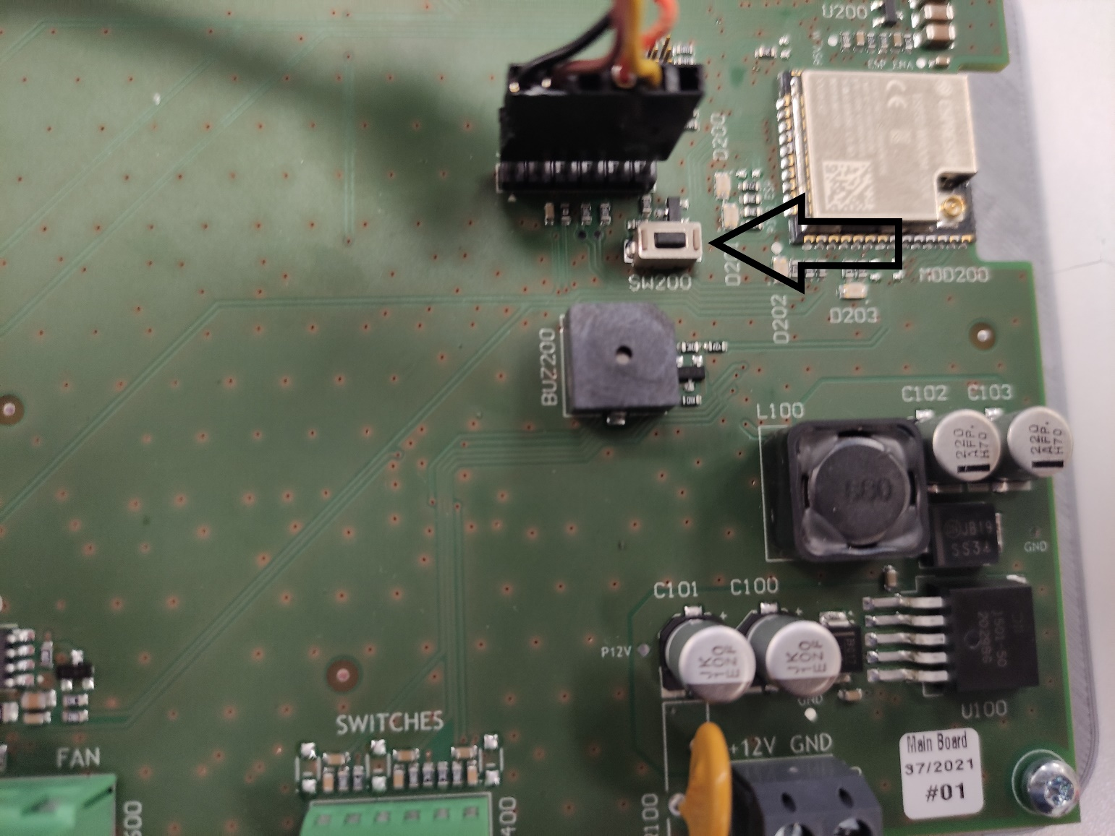

1. You should see progress on the progress bar and status change to Download.

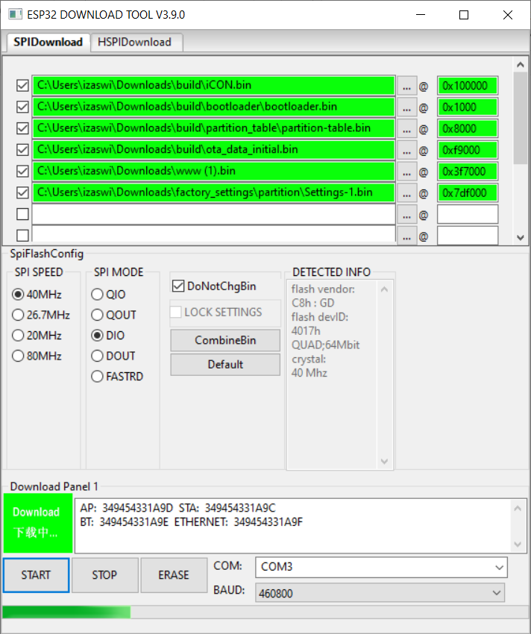

1. If everything is ok you will see status Finish.

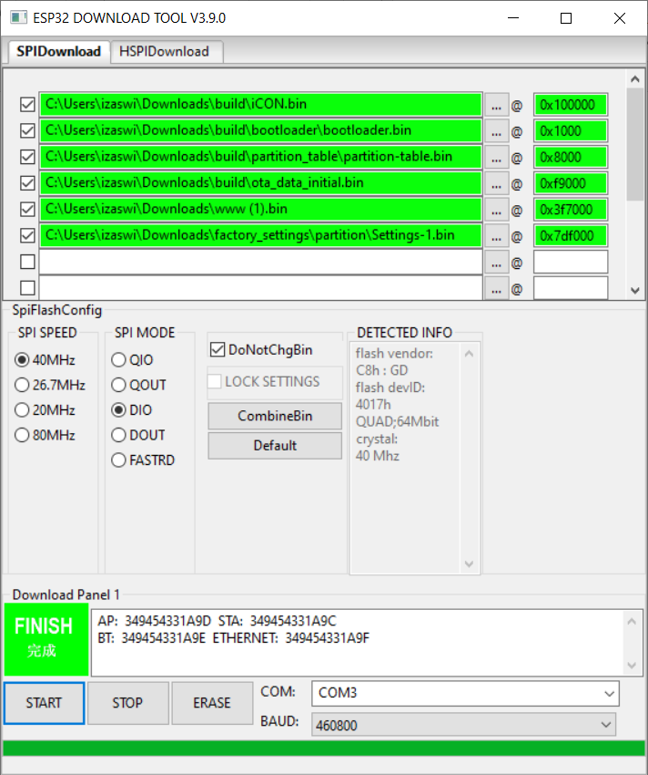

1. Close ESP32 DOWNLOAD TOOL**.**
2. Unplug ttl232 cable.
3. Turn off device from power for about 30 seconds.
4. Turn on device.
5. New firmware has been uploaded.